

**QuizzyNest**

Web Fundamentals

Topic: - Create a simple quiz game. Store questions and answers in an array or database, present questions to the user, and provide feedback on their answers.

Group No. - 1



**Habiba Ansari Ashlesha Nanaware Komal Agrahari Riddhi Lokegaonkar Pratik More**

**Aditya Jagtap**

**Members:**

Quiz Website: -

Program –

<!DOCTYPE html>

<html>

<head>

    <title>QuizzyNest</title>

    <style>

        header

            {

                color: #000000;

                padding: 10px 0;

            }

            .top-nav

            {

                display: flex;

                justify-content: space-between;

                align-items: center;

                padding: 0 20px;

            }

            .nav-links

            {

                list-style: none;

                display: flex;

            }

            .nav-links li

            {

                margin-right: 20px;

                width: 150px; height: 100px;

            }

            .nav-links a

            {

                font-size:large;

                font-family: 'Montserrat', sans-serif;

                text-decoration: none;

                color: rgb(255, 255, 255);

                transition: color 0.3s ease-in-out;

            }

            body

            {

                background-size: cover;

                background: linear-gradient(57deg, #8711c1 , #2472fc );

            }

            #p

            {

                color: white;

                font-size: xx-large;

                font-family:'Montserrat', sans-serif;

                text-shadow: 1.5px 1.5px rgb(255, 0, 247);

            }

            #p1

            {

                color: white;

                font-size: 100px;

                font-weight: 100;

                font-family:'Montserrat', sans-serif;

                text-align: center;

                text-shadow: 3px 3px rgb(255, 0, 247);

            }

            #p2

            {

                color: white;

                font-size: 40px;

                font-family:'Montserrat', sans-serif;

                text-align: center;

            }

            .dropdown

            {

                position: relative;

                display: inline-block;

            }

            .dropdown-content

            {

                display: none;

                position: absolute;

                background-color: rgb(244, 170, 255);/* Background color for the dropdown */

                min-width: 160px;

                box-shadow: 0px 8px 16px 0px rgb(255, 255, 255);

                z-index: 1;

            }

            .dropdown:hover .dropdown-content

            {

                display: block;

            }

            .dropdown-content a

            {

                color: #ffffff; /* Text color for the dropdown links */

                padding: 12px 16px;

                text-decoration: none;

                display: block;

                text-shadow: 1px 1px rgba(157, 0, 255, 0.684);

            }

            .dropdown-content a:hover

            {

                background-color: #f1f1f15c; /* Background color for hover state */

            }

             a:hover

            {

                background-color: #f1f1f15c; /* Background color for hover state */

            }

    </style>

</head>

<body>

    <br>

    <header>

        <nav class="top-nav">

            <div>

                <p id="p">QuizzyNest</p>

            </div>

            <ul class="nav-links">

                <li class="dropdown">

                    <a href="#">Categories&nabla;</a>

                    <div class="dropdown-content">

                        <a href="English.html">English</a>

                        <a href="geography.html">Geography</a>

                        <a href="solar system.html">Solar System</a>

                        <a href="pop culture.html">Pop Culture</a>

                        <a href="humour testing.html">Humour Testing</a>

                        <a href="GK.html">GK</a>

                    </div>

                </li>

                <li><a href="About Us.html">About Us</a></li>

                <li><a href="quizgames.html">Quiz Games</a></li>

            </ul>

        </nav>

    </header>

    <p id="p1">

        <b>Welcome to QuizzyNest!</b>

    </p>

    <p id="p2">

        Where Knowledge Meets Fun!

    </p>

    <br><br><br><br><br><br><br><br>

</body>

</html>

Output –

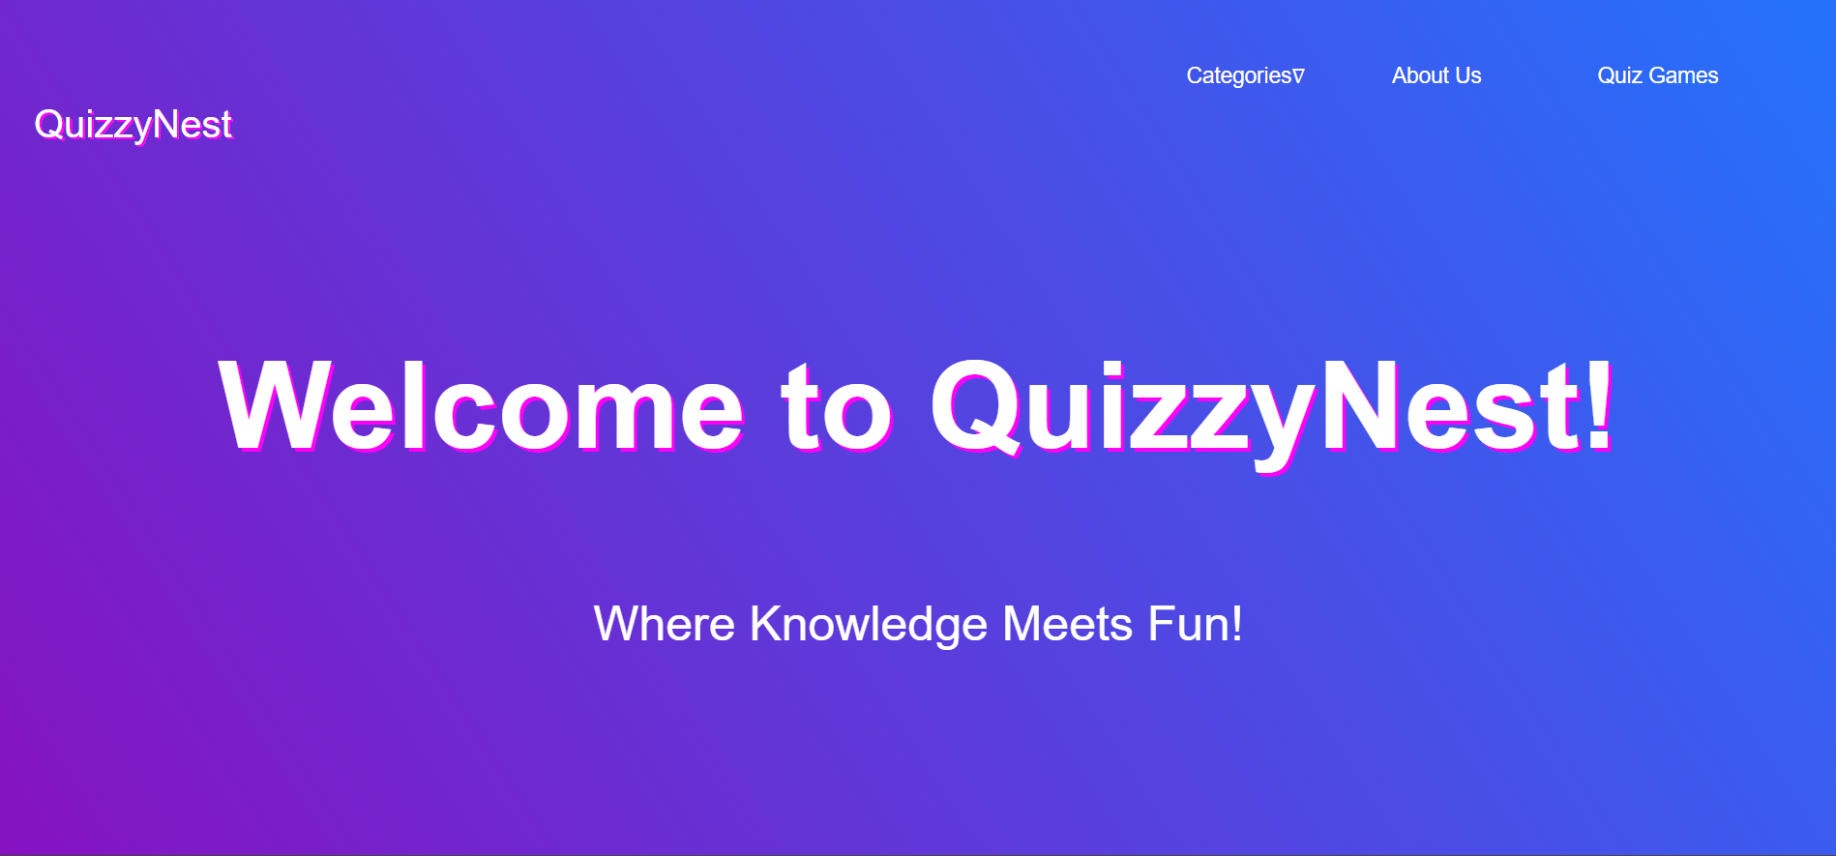

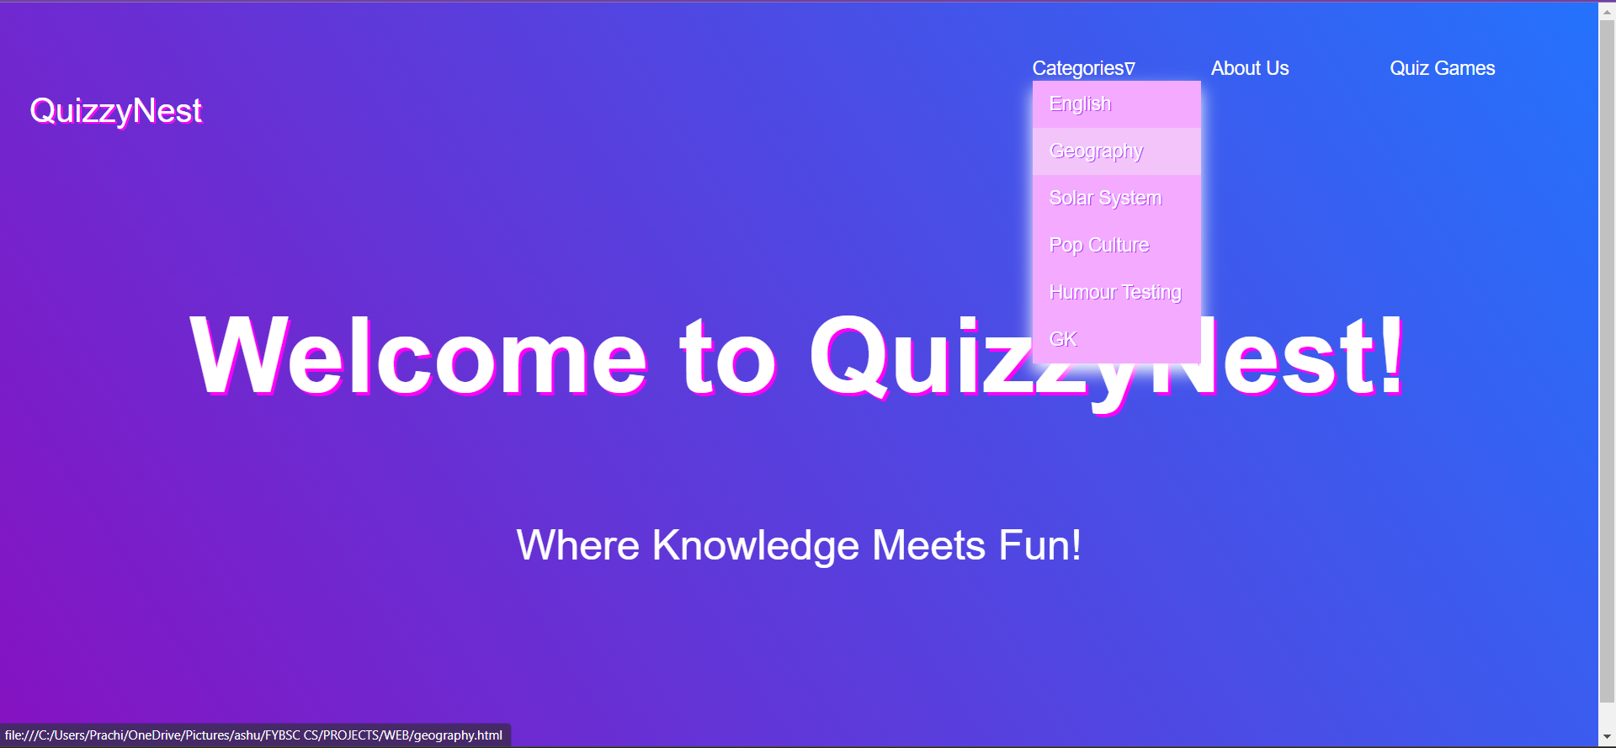

Overview

This document presents an HTML and CSS for the QuizzyNest website, a platform that offers quizzes on various

topics.

HTML Structure

The HTML structure of the QuizzyNest website is organized as follows:

<!DOCTYPE html>

Specifies the document type as HTML5.

<html>

Represents the root element of the HTML document.

<head>

Contains metadata and links to external resources.

<title>

Sets the title of the webpage displayed in the browser's title bar.

<style>

Embeds internal CSS styles for the webpage.

<body>

Holds the visible content of the webpage.

<header>

Defines the website's header section, including the navigation bar and page title.

<nav class="top-nav">

Houses the top navigation bar.

<div>

Contains the QuizzyNest logo.

<ul class="nav-links">

An unordered list for navigation links.

<li class="dropdown">

List item with a dropdown menu for categories.

<a href="#">

Navigation link for categories with a dropdown arrow.

<div class="dropdown-content">

The dropdown menu containing category links.

<a href="English.html">, <a href="geography.html">, ...

Links to specific categories.

<li>

List item for the "About Us" page link.

<li>

List item for the "Quiz Games" page link.

<p id="p1">

A prominent welcome message with the website's title.

<p id="p2">

A tagline emphasizing the website's theme.

CSS Styling

The CSS styles are defined within the <style> element in the <head> section of the HTML document. Here are key styling details:

* The header has a dark background color, and navigation links are styled in white with hover effects.
* The body background utilizes a gradient color scheme.
* Various text elements (#p, #p1, #p2) are styled with different font sizes, colors, and text shadows to enhance readability and visual appeal.
* The dropdown menu in the navigation bar has a background color and hover effect for interactive user experience.
* The a:hover selector applies a background color on hover for all links, indicating interactivity.

QUIZ: -

Program –

<!DOCTYPE html>

<html>

<head>

    <title>QuizzyNest</title>

            <link rel="stylesheet" type="text/css" href="STYLE.CSS">

            <link rel="stylesheet" href="https://cdnjs.cloudflare.com/ajax/libs/font-awesome/4.7.0/css/font-awesome.min.css">

</head>

<body>

    <i class="fa fa-home" id="a"></i>

    <a id="a" href="QUIZ.html">__Home</a>

    <div class="quiz-container" style="display:none;">

        <div class="question"></div>

        <div class="options"></div>

        <div id="score"></div>

        <div class="timer"></div>

        <button id="next-button">Next</button>

    </div>

    <div class="start-container">

        <h1 id="h1">Welcome to the Quiz</h1>

        <p id="p">Click the button below to start the quiz.</p>

        <button id="start-button">Start Quiz</button>

    </div>

    <script>

        const questions =

        [

            {

                question: "1) Who is the current President of the United States?",

                options: ["A) Joe Biden", "B) Donald Trump", "C) Barack Obama", "D) George Bush"],

                answer: "A) Joe Biden",

            },

            {

                question: "2) Which country is famous for the Pyramids of Giza?",

                options: ["A) Greece", "B) Egypt", "C) Mexico", "D) Italy"],

                answer: "B) Egypt",

            },

            {

                question: "3) What is the largest bird in the world?",

                options: ["A) Bald Eagle", "B) Ostrich", "C) Penguin", "D) Sparrow"],

                answer: "B) Ostrich",

            },

            {

                question: "4) What is the longest river in the world?",

                options: ["A) Nile", "B) Amazon", "C) Mississippi", "D) Yangtze"],

                answer: "A) Nile",

            },

            {

                question: "5    ) What is the capital of Japan?",

                options: ["A) Beijing", "B) Seoul", "C) Tokyo", "D) Bangkok"],

                answer: "C) Tokyo",

            },

            {

                question: "6) Which gas makes up the majority of Earth's atmosphere?",

                options: ["A) Oxygen", "B) Carbon Dioxide", "C) Nitrogen", "D) Hydrogen"],

                answer: "C) Nitrogen",

            },

            {

                question: "7) What is the largest mammal in the world?",

                options: ["A) African Elephant", "B) Giraffe", "C) Blue Whale", "D) Polar Bear"],

                answer: "C) Blue Whale",

            },

            {

                question: "8) Who painted the Mona Lisa?",

                options: ["A) Vincent van Gogh", "B) Leonardo da Vinci", "C) Pablo Picasso", "D) Michelangelo"],

                answer: "B) Leonardo da Vinci",

            },

            {

                question: "9) Which planet is known as the 'Morning Star' or 'Evening Star'?",

                options: ["A) Mars", "B) Venus", "C) Mercury", "D) Neptune"],

                answer: "B) Venus",

            },

            {

                question: "10) What is the longest mountain range in the world?",

                options: ["A) Andes", "B) Rocky Mountains", "C) Himalayas", "D) Alps"],

                answer: "A) Andes",

            },

        ];

        let currentQuestionIndex = 0;

        let score = 0;

        let countdown;

        const questionElement = document.querySelector(".question");

        const optionsElement = document.querySelector(".options");

        const scoreElement = document.getElementById("score");

        const nextButton = document.getElementById("next-button");

        const startButton = document.getElementById("start-button");

        startButton.addEventListener("click", () => {

            startQuiz();

        });

        function startQuiz() {

            const startContainer = document.querySelector(".start-container");

            const quizContainer = document.querySelector(".quiz-container");

            startContainer.style.display = "none";

            quizContainer.style.display = "block";

            displayQuestion();

        }

        function displayQuestion() {

            if (currentQuestionIndex < questions.length) {

                const currentQuestion = questions[currentQuestionIndex];

                questionElement.textContent = currentQuestion.question;

                optionsElement.innerHTML = "";

                currentQuestion.options.forEach((option, index) => {

                    const optionElement = document.createElement("div");

                    optionElement.textContent = option;

                    optionElement.classList.add("option");

                    optionElement.addEventListener("click", () => checkAnswer(option));

                    optionsElement.appendChild(optionElement);

                });

                startCountdown();

                nextButton.style.display = "none"; // Hide the "Next" button initially

            } else {

                endQuiz();

            }

        }

        function startCountdown() {

            let timeLeft = 15;

            countdown = setInterval(() => {

                if (timeLeft <= 0) {

                    clearInterval(countdown);

                    checkAnswer("");

                } else {

                    const timerElement = document.querySelector(".timer");

                    timerElement.textContent = `Time Left: ${timeLeft} seconds`;

                }

                timeLeft--;

            }, 1000);

        }

        function checkAnswer(selectedOption) {

            clearInterval(countdown);

            const currentQuestion = questions[currentQuestionIndex];

            if (selectedOption === currentQuestion.answer) {

                score++;

            }

            currentQuestionIndex++;

            nextButton.style.display = "block"; // Show the "Next" button after answering

        }

        function endQuiz() {

            questionElement.textContent = "Quiz Completed!";

            optionsElement.innerHTML = "";

            scoreElement.textContent = `Your Score: ${score} out of ${questions.length}`;

            nextButton.style.display = "none"; // Hide the "Next" button when the quiz is completed.

        }

        nextButton.addEventListener("click", () => {

            displayNextQuestion();

        });

        function displayNextQuestion() {

            if (currentQuestionIndex < questions.length) {

                clearInterval(countdown);

                displayQuestion();

            } else {

                endQuiz();

            }

        }

    </script>

</body>

</html>

Output –

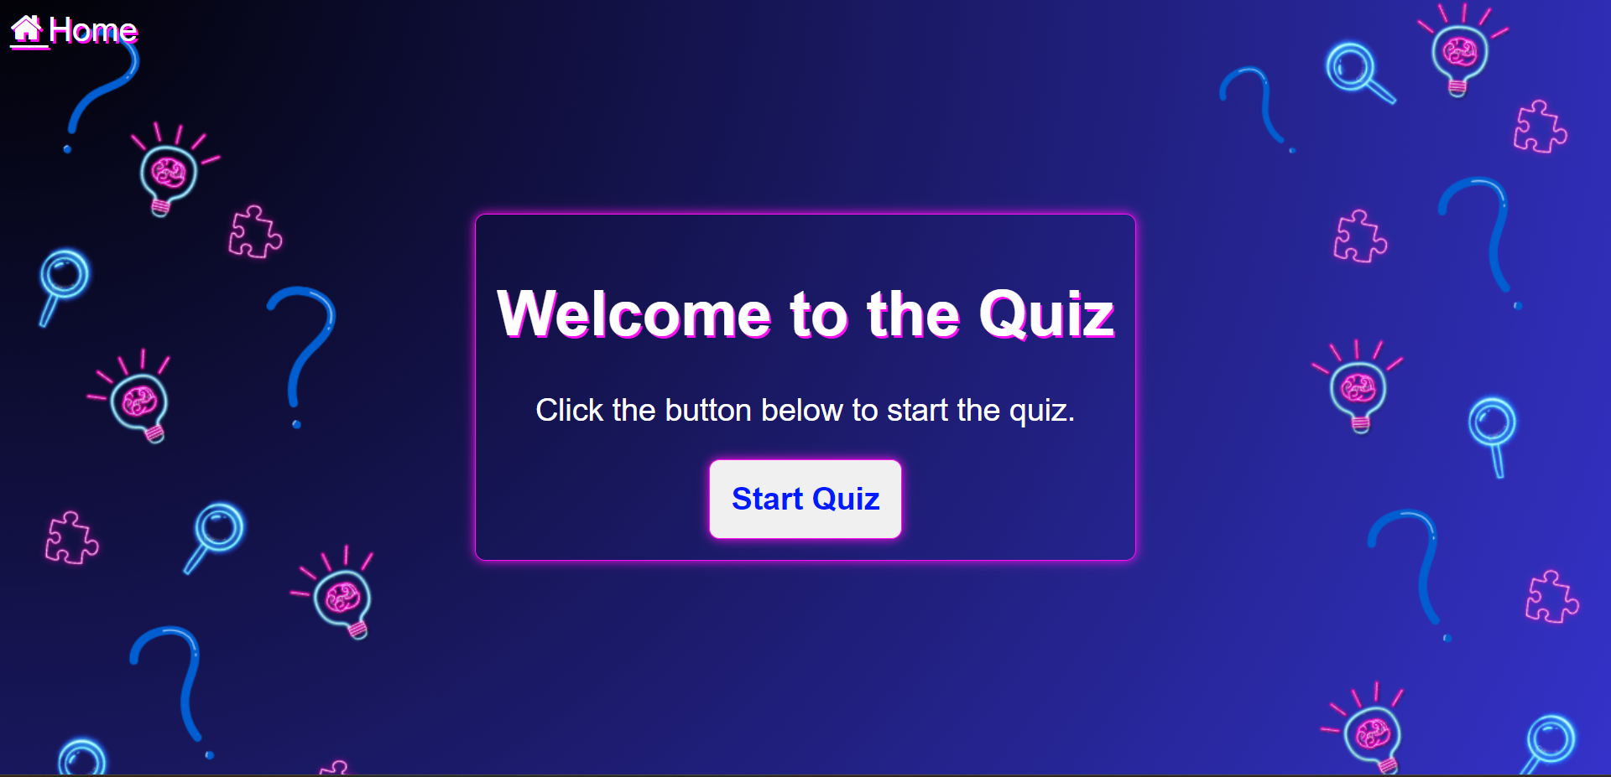

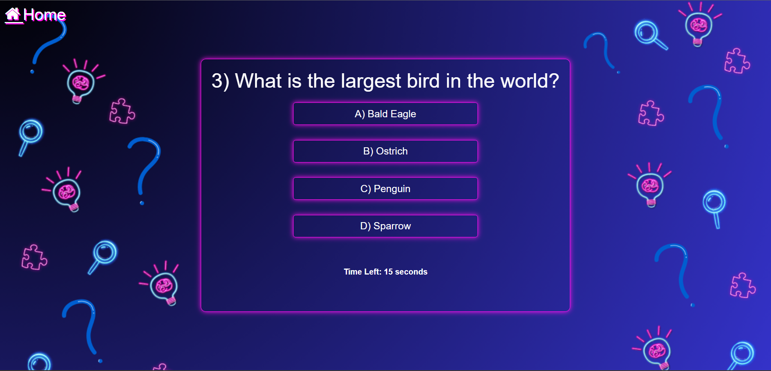

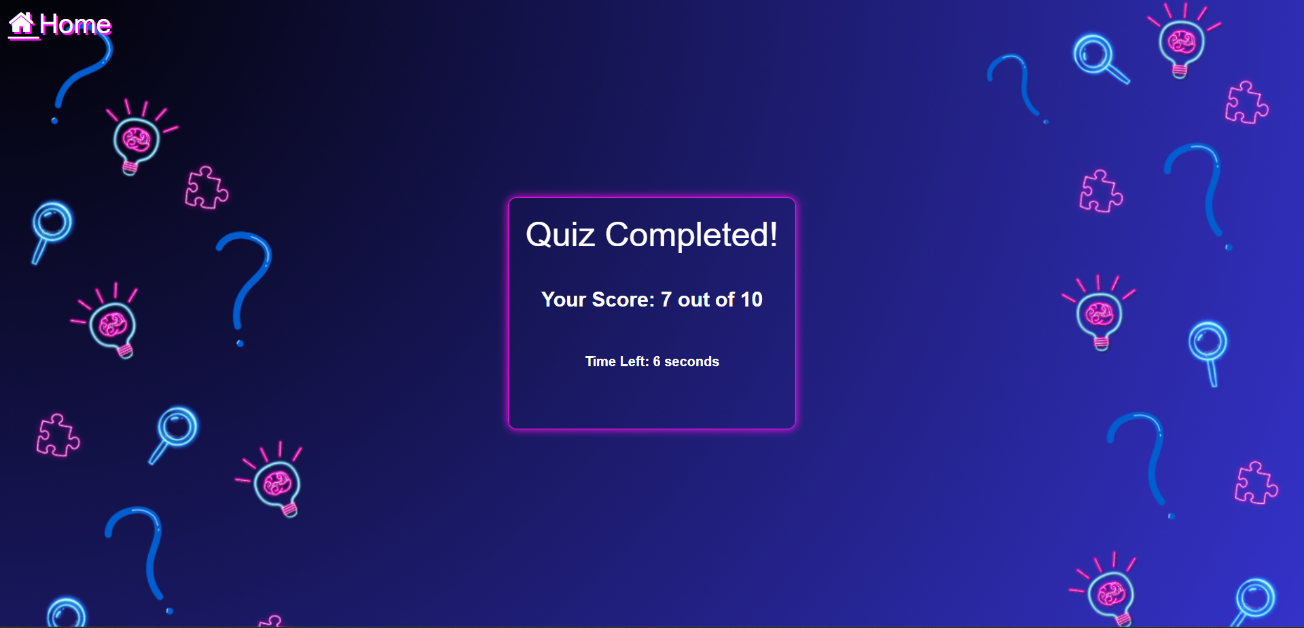

Overview

This code presents an HTML and JavaScript project for the QuizzyNest Quiz App. The QUIZ allows users to take a quiz with multiple-choice questions.

HTML Structure

The HTML structure of the QuizzyNest Quiz App includes the following elements:

<title>: Sets the title of the webpage.

External CSS and Font Awesome libraries are linked for styling and icons.

<body>: Contains the entire content of the QUIZ.

<i class="fa fa-home" id="a"></i> and <a id="a" href="QUIZ.html">__Home</a>: Represents a home button to navigate back to the home page.

<div class="quiz-container" style="display:none;">: A container for displaying quiz questions and options. Initially hidden.

<div class="start-container">: A container for the start screen with a welcome message and a button to start the quiz.

JavaScript Functionality

The JavaScript code provides the functionality for the QuizzyNest Quiz :

* It defines an array of quiz questions with options and correct answers.
* Variables are declared to keep track of the current question index, user score, and countdown timer.
* Event listeners are set up to respond to user interactions, such as clicking the "Start Quiz" button and selecting answer options.
* Functions are created to start the quiz, display questions, start the countdown timer, check user answers, and end the quiz.
* The app displays one question at a time and keeps track of the user's score.
* When the quiz is completed, the app displays the user's score and hides the "Next" button.
* The "Next" button allows the user to proceed to the next question until the quiz is completed.

CSS FOR QUIZ: -

Program –

body {

    font-family: 'Montserrat', sans-serif;

    background: url('back.png') no-repeat center center fixed;

    background-size: cover;

    display: flex;

    justify-content: center;

    align-items: center;

    height: 100vh;

    margin: 0;

    background-color: rgb(0, 0, 52);

}

.start-container {

    border-radius: 10px;

    padding: 20px;

    border: 1px solid rgb(255, 16, 240);

    box-shadow: 0 0 10px rgb(255, 16, 240);

    text-align: center;

}

.quiz-container {

    border-radius: 10px;

    padding: 20px;

    border: 1px solid rgb(255, 16, 240);

    box-shadow: 0 0 10px rgb(255, 16, 240);

    text-align: center;

}

.question {

    font-family: 'Montserrat', sans-serif;

    font-size: 40px;

    margin-bottom: 20px;

    color: #ffffff;

    font-weight: 500;

}

.options {

    display: flex;

    flex-wrap: wrap;

    justify-content: center;

    gap: 20px;

    margin-top: 10px;

    color: #ffffff;

}

.option {

    font-size: 20px;

    font-weight: 300;

    cursor: pointer;

    padding: 10px 20px;

    border: 1px solid rgb(255, 16, 240);

    border-radius: 5px;

    box-shadow: 0 0 10px rgb(255, 16, 240);

    margin-bottom: 10px;

    flex-basis: calc(50% - 20px);

}

#score {

    font-size: 24px;

    font-weight: bold;

    margin-top: 20px;

    color: #fffefe;

}

.timer {

    font-size: 16px;

    font-weight: bold;

    margin-top: 50px;

    color: #ffffff;

    margin-bottom: 50px;

}

#next-button {

    font-size: 18px;

    margin-top: 20px;

    cursor: pointer;

    background-color: #0074cc;

    color: white;

    padding: 10px 20px;

    border: none;

    border-radius: 5px;

    display: none;

}

#h1 {

    font-size: 60px;

    font-family: 'Montserrat', sans-serif;

    color: white;

    text-shadow: 2px 2px rgb(255, 16, 240);

}

#p {

    font-size: 30px;

    font-family: 'Montserrat', sans-serif;

    color: white;

}

#start-button {

    font-size: 30px;

    font-family: 'Montserrat', sans-serif;

    font-weight: bolder;

    color: rgb(0, 26, 255);

    border-radius: 10px;

    padding: 20px;

    border: 1px solid rgb(255, 16, 240);

    box-shadow: 0 0 10px rgb(255, 16, 240);

    text-align: center;

}

#a {

    position: absolute;

    top: 10px;

    left: 10px;

    text-decoration: none;

    color: white;

    font-stretch: ultra-expanded;

    font-size: xx-large;

    text-shadow: 2px 2px rgb(255, 16, 240);

}

Output –







CSS Styling

* <body>

Sets the background image with a fixed cover and centers the content.

Uses the Montserrat font as the default font family.

Initializes a flex container for content alignment and sets a dark background color.

* .start-container

Represents the container for the start screen, where users can begin the quiz.

Styled with rounded corners, padding, borders, box-shadow, and text alignment.

* .quiz-container

Represents the container for the quiz questions.

Styled similarly to the start container with rounded corners, padding, borders, and box-shadow.

* .question

Styles the question text with Montserrat font, size, color, and margin.

* .options

Creates a flex container to display answer options.

Uses flex-wrap and justifies content to center align options.

Sets the color for option text.

* .option

Styles individual answer options with font size, cursor, padding, border, border-radius, and box-shadow.

Defines flex-basis to manage option width.

Adds a margin to separate options vertically.

* #score

Styles the score display with font size, font weight, margin, and color.

* .timer

Styles the timer display with font size, font weight, margin, color, and margin-bottom.

* #next-button

Styles the next button with font size, cursor, background color, text color, padding, border, and border-radius.

Initially set to display none.

* #h1

Styles the primary header with font size, font family, color, and text shadow.

* #p

Styles general text paragraphs with font size, font family, and color.

#start-button

Styles the start button with font size, font family, font weight, color, border-radius, padding, border, box-shadow, and text alignment.

* #a

Styles an anchor link in the top-left corner with position, text decoration, color, font stretch, font size, and text shadow.

QUIZ GAMES: -

Program –

<!DOCTYPE html>

<html lang="en">

<head>

    <meta charset="UTF-8">

    <meta name="viewport" content="width=device-width, initial-scale=1.0">

    <title>Quiz Games</title>

    <style>

        html{

            scroll-behavior: smooth;

        }

        header {

            color: #fff;

            text-align: center;

            text-shadow: 1.5px 1.5px rgb(255, 16, 240);

            padding: 20px 0;

            font-size: 100px;

        }

        body {

            background: linear-gradient(57deg, #8711c1 , #2472fc );

            text-align: center;

        }

        .image-container {

            text-align: center;

            display: inline-block;

            margin: 10px;

            border: 5px solid salmon;

            border-radius: 25px;

            color: #ffffff;

            transition: background-color 0.2s ease-in-out;

        }

        .image-container:hover {

            background-color: rgba(255, 255, 255, 0.747);

        }

        img {

            max-width: auto;

            border-radius: 25px;

        }

        .image-description {

            text-align: center;

            font-size: xx-large;

            font-family: 'Montserrat', sans-serif;

            font-weight: bold;

            text-decoration: none;

            color: #ffffff;

        }

        .a{

            font-size: xx-large;

            color: #ffffff;

            text-decoration: none;

            display: flex;

            justify-content: space-between;

            align-items: center;

            padding: 0 20px;

        }

    </style>

</head>

<body>

    <header>

        <a class="a" href="QUIZ.html">QuizzyNest</a>

        <b>Quiz Games</b>

    </header>

    <div class="image-container">

        <a href="https://poki.com/en/g/brain-test-tricky-puzzles">

            <img src="Brain-Test.webp" alt="Image 1" width="450px">

            <div class="image-description">Brain Test Tricky Puzzle Game</div>

        </a>

    </div>

    <div class="image-container">

        <a href="https://poki.com/en/g/the-impossible-quiz">

            <img src="impossible quiz.jpg" alt="Image 2" width="420px">

            <div class="image-description">The Impossible Quiz</div>

        </a>

    </div>

    <br>

    <div class="image-container">

        <a href="https://www.crazygames.com/game/trivia-crack">

            <img src="trivia.avif" alt="Image 3">

            <div class="image-description">Trivia Crack</div>

        </a>

    </div>

    <div class="image-container">

        <a href="https://www.crazygames.com/game/brain-teaser">

            <img src="brain teaser.avif" alt="Image 4">

            <div class="image-description">Brain Teaser</div>

        </a>

    </div>

    <br>

    <div class="image-container">

        <a href="https://poki.com/en/g/flags-quiz">

            <img src="flag.png" alt="Image 5" width="460px">

            <div class="image-description">Flags Quiz</div>

        </a>

    </div>

    <div class="image-container">

        <a href="https://poki.com/en/g/time-quiz">

            <img src="time quiz" alt="Image 6" width="490px">

            <div class="image-description">Time Quiz</div>

        </a>

    </div>

    <br>

    <div class="image-container">

        <a href="https://www.crazygames.com/game/atlas-quiz">

            <img src="atlas quiz.avif" alt="Image 7">

            <div class="image-description">Atlas Quiz</div>

        </a>

    </div>

    <div class="image-container">

        <a href="https://www.crazygames.com/game/world-s-capitals-quiz">

            <img src="world quiz.avif" alt="Image 8">

            <div class="image-description">World's Capitals Quiz</div>

        </a>

    </div>

    <br>

    <div class="image-container">

        <a href="https://www.crazygames.com/game/quizzland-lite">

            <img src="quizzland.avif" alt="Image 9">

            <div class="image-description">Quizzland Trivia</div>

        </a>

    </div>

    <div class="image-container">

        <a href="https://www.crazygames.com/game/stupidity-test">

            <img src="stupidity test.avif" alt="Image 10">

            <div class="image-description">Stupidity Test</div>

        </a>

    </div>

</body>

</html>

Output –

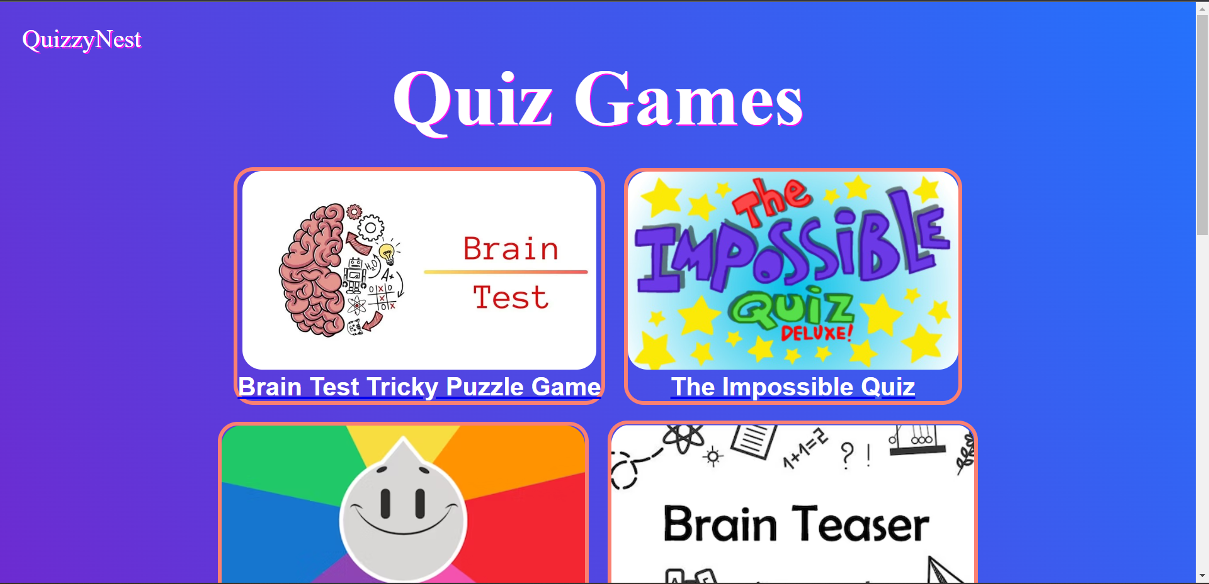

Overview

The Quiz Games Page provides a user-friendly interface to explore and play various quiz games.

The homepage includes a title and navigation link back to the main QuizzyNest page.

Each quiz game is presented in a container with an image and description. Users can click on the links to access and play their preferred quiz games.

HTML Structure

The HTML structure of the Quiz Games Page includes the following elements:

* <head>: Contains metadata like charset, viewport settings, and the page title.
* External CSS stylesheet is linked for styling.
* <body>: Contains the entire content of the page.
* <header>: Displays the website title and a link back to the home page.
* Quiz game sections: Each quiz game is represented by an <div> element with the class "image-container."
* Inside each quiz game container, there is an <a> element linking to the game, an <img> element displaying an image related to the game, and a <div> element with class "image-description" displaying the game's description.

CSS Styling

The CSS styling for the Quiz Games Page includes:

* Smooth scrolling (scroll-behavior: smooth) for navigation.
* Styling for the <header> element with text color, text shadow, padding, and font size.
* Background color and text alignment for the <body> element.
* Styling for the quiz game containers with border, border-radius, color transition on hover, and text alignment.
* Styling for images with a maximum width and border radius.
* Styling for the game descriptions with font size, font family, font weight, text decoration, and color.
* Styling for links with font size, color, and text decoration.

About Us: -

Program –

<!DOCTYPE html>

<html lang="en">

<head>

    <meta charset="UTF-8">

    <meta name="viewport" content="width=device-width, initial-scale=1.0">

    <title>About Us</title>

    <style>

        html{

            scroll-behavior: smooth;

        }

        body {

            font-family: Arial, sans-serif;

            margin: 0;

            padding: 0;

            background-size: cover;

            background: linear-gradient(57deg, #8711c1 , #2472fc );

        }

        header {

            color: #fff;

            text-align: center;

            text-shadow: 1.5px 1.5px rgb(255, 16, 240);

            padding: 20px 0;

            font-size: 50px;

        }

        .container {

            max-width: 800px;

            margin: 20px auto;

            padding: 20px;

            background-color: #fff;

            border: 2px solid rgb(255, 16, 240);

            box-shadow: 0 0 50px rgb(255, 16, 240);

        }

        .h1 {

            font-size: 50px;

            margin-bottom: 20px;

            text-align: center;

            font-stretch: ultra-expanded;

            text-shadow: 2px 2px rgb(255, 16, 240);

        }

        p {

            font-size: 16px;

            line-height: 1.6;

        }

        a {

            font-size: xx-large;

            color: #ffffff;

            text-decoration: none;

            display: flex;

            justify-content: space-between;

            align-items: center;

            padding: 0 20px;

        }

        a:hover {

            text-decoration: underline;

        }

    </style>

</head>

<body>

    <header>

        <a href="QUIZ.html">QuizzyNest</a>

        About Us

    </header>

    <div class="container">

        <marquee class="h1">Welcome to our Website!</marquee>

        <p>

            At our <u>QuizzyNest</u>, we are passionate about knowledge and learning through fun and engaging quizzes. Our mission is to provide a platform where users can test their knowledge, learn new facts, and have a great time while doing so.

        </p>

        <br>

        <h2>What We Offer:</h2>

        <p>

            <b><u>1. Diverse Quiz Categories:</u></b>

            We offer a wide range of quiz categories to cater to various interests and knowledge levels. Whether you're a history buff, a science enthusiast, a movie fanatic, or just looking for a fun challenge, we have quizzes for you.

            <br><br>

            <b><u>2. Educational Content:</u></b>

            Our quizzes are designed not only for entertainment but also for education. You'll find informative explanations and facts to expand your understanding of each topic.

            <br><br>

            <b><u>3. User-Friendly Experience:</u></b>

           We've created a user-friendly and intuitive platform that makes taking quizzes a breeze. You can easily navigate through our site, choose your favorite quizzes, and track your progress.

            <br><br>

        <h2>Our Team</h2>

        <p>

            We are a dedicated team of quiz enthusiasts who are passionate about creating a fun and informative experience for our users. Our team includes quiz experts, content creators, and tech-savvy individuals who work tirelessly to bring you the best quizzes on the web.

        </p>

        <br>

        <img src="C:\Users\Prachi\Downloads\img.png" width="750px" height="500px">

        <h3 style="text-align: center;">

            Thank you for visiting, and we hope you enjoy your time on our quiz platform!

        </h3>

    </div>

</body>

</html>

Output –

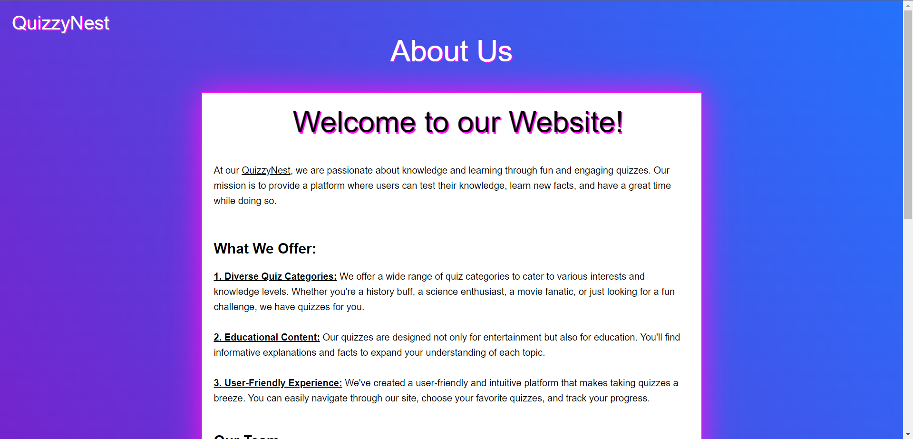

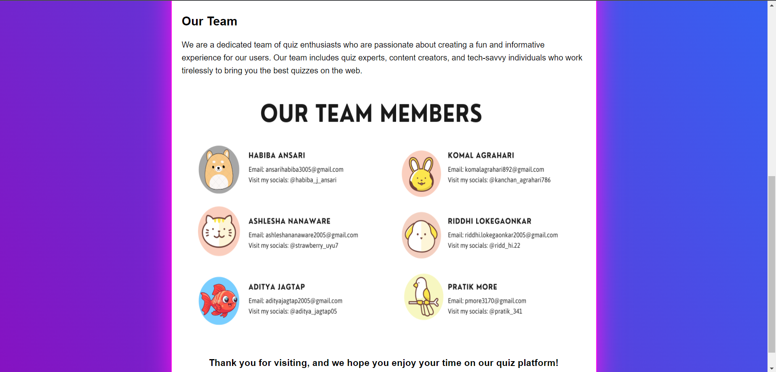

Overview

The About Us page provides visitors with information about QuizzyNest's mission and offerings. It highlights the diversity of quiz categories available on the platform and emphasizes the educational aspect of the quizzes. The page also introduces the website's team and includes an image of the team members.

HTML Structure

The HTML structure of the About Us page includes the following elements:

* <head>: Contains metadata like charset, viewport settings, and the page title.
* External CSS stylesheet is linked for styling.
* <body>: Contains the entire content of the About Us page.
* <header>: Displays the website title and a link back to the main QuizzyNest page.
* <div class="container">: Contains the main content of the About Us page.
* <marquee class="h1">: Displays a scrolling welcome message with styling.
* <p> elements: Provide information about the website's mission and offerings.
* <h2> elements: Highlight key features of the website.
* <h2> element: Indicates the start of the "Our Team" section.
* <p> element: Provides information about the website's team.
* <img> element: Displays an image of the team.
* <h3> element: Displays a closing message.

CSS Styling

The CSS styling for the About Us page includes:

* Smooth scrolling (scroll-behavior: smooth) for navigation.
* Styling for the <header> element with text color, text shadow, padding, and font size.
* Styling for the <div class="container"> element with maximum width, margin, padding, background color, border, and box shadow.
* Styling for the <marquee class="h1"> element with font size, margin, text alignment, font stretch, and text shadow.
* Styling for <p> elements with font size and line height.
* Styling for <a> elements with font size, color, text decoration, and display properties.
* Hover effect for <a> elements to underline text when hovered.